# Lab:CSS-Basics

*In today's exercise, we will build a very simple page in which we will practice everything from the lesson learned about HTML lecture. We will build it step by step following the instructions below.*

## Heading Stage Upgrade

* Use your HTML code from the previous lecture
* Make your headings (**h1**) **inline** with **color blue**

### Examples



## Paragraph Stage Upgrade

* Use your HTML code from the previous lecture
* Make all **paragraphs** with **internal style** with **color darkviolet**

### Examples

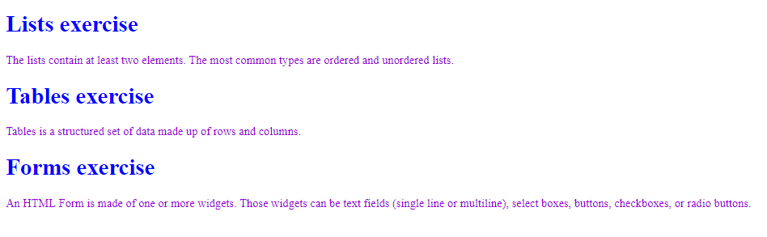

## Code Refactor

* Delete all the styles you have made
* Open the styles from the HTML lecture
* Link the CSS file into your HTML file
* Add in the CSS file, the styles you have deleted

## List/Table/Form Stage Upgrade

* Use your HTML code from the previous lecture
* Make all list elements (<li>) with solid border in yellow color

### Examples

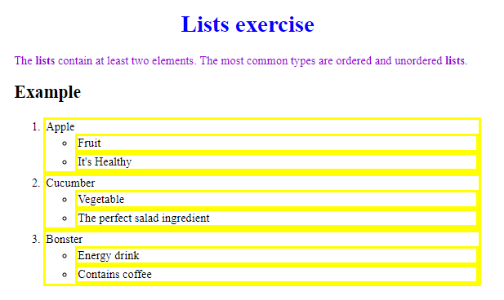

* Use your HTML code from the previous lecture
* Make all your **spans** with **dotted border** in **darkcyan color**

### Examples

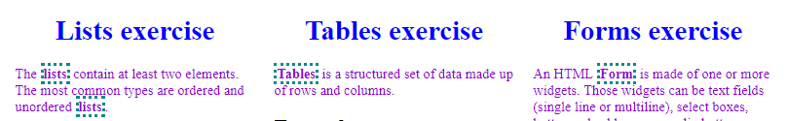

## Color Blocks

* Use the following HTML

|  |
| --- |
| <**body**> <**div id="green"**>green block</**div**> <**div id="blue"**>blue block</**div**> <**div id="red"**>red block</**div**> <**div id="purple"**>purple block</**div**> <**div id="orange"**>orange block</**div**> </**body**> |

### Examples

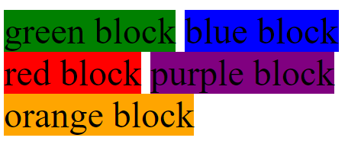

## Color Blocks Upgrade

* Use the HTML and CSS from the previous problem
* Make all **<div> padding 20px** on each side, refresh the browser
* Set **3px** **solid**, **border** with **yellow color**, refresh the browser
* Now set **margin** with **20px** for each side, refresh the browser

### Examples

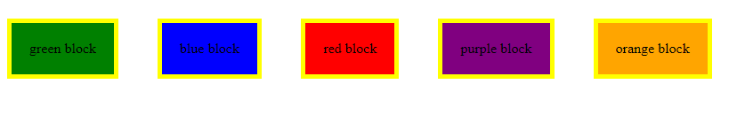

## Cool Fonts

* Use the code from the previous problem
* Go to <https://fonts.google.com/>
* Pick a font of your preference
* Click on the "+" in the top-right corner
* Click on the new opened tab
* Copy the link in your HTML <head>
* Copy the font family in your <div>

### Examples

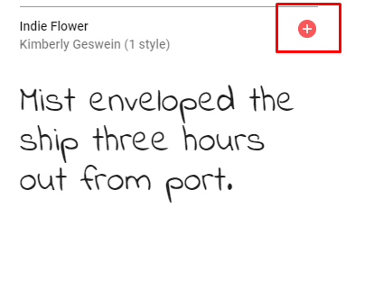



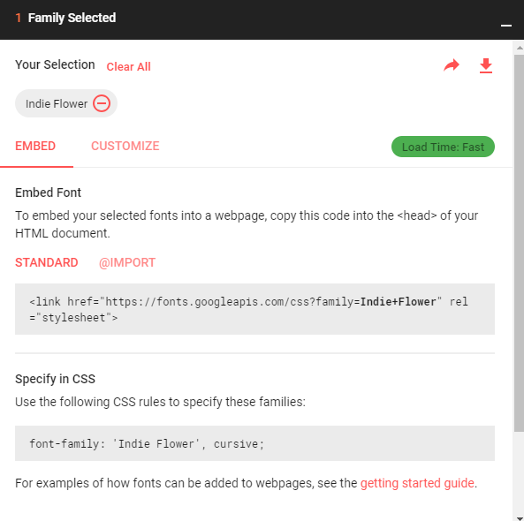

## Cool Fonts Upgrade

* Use the code from the previous problem
* Set **large font-size**
* Set **bold font-weight**

### Examples

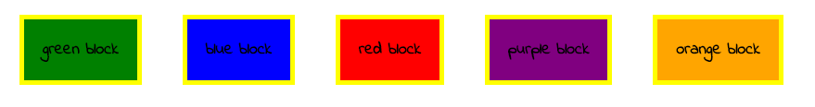

* Use the code from the previous problem
* In your **<div>** set **white color**

### Examples



*And we are done! ☺*